Side scroller game on PIXI

Example:

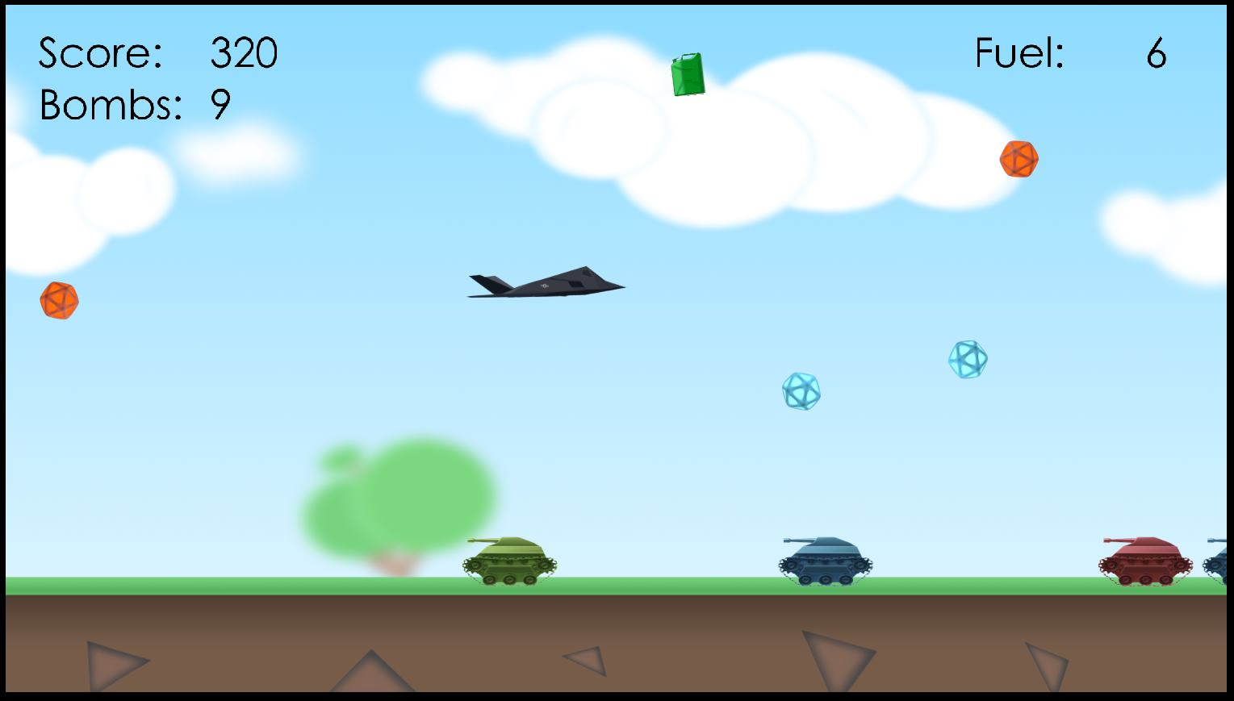 Perspective – top view or side view, you decide. The picture is just an example – it’s not necessary to have all the objects that are shown on the picture. However the following is mandatory:

* Player – moves up and down and the background is scrolling from right to left
* Obstacle – if the player touches the obstacle the game restarts itself
* Enemy - if the player touches the enemy the game restarts itself. It may fire a projectile that may kill the player

UI counts the distance passed.